Name: Swathi Reddy Konatham Z-Id: Z1864290

**H1B Visa Petitions 2011-2016**

**Links to the dataset:**

<https://www.kaggle.com/nsharan/h-1b-visa>

<https://www.foreignlaborcert.doleta.gov/performancedata.cfm>

**Context:**

H1B is a non-immigrant visa which allows the foreign students or professionals to work in United States. For a foreign worker to apply for H1-B visa, a US employer must offer them a job and submit a petition for an H-1B visa to the US immigration department. This project work illustrates and visualizes few trends in the number of H1B application filed each year by each employer in the United States.

**Content:**

Kaggle dataset contains H-1B petition data form the years 2011 to 2016, with approximately 3 million records overall. Below is the list of attributes and it’s description that are listed in the dataset.

Description of Columns:

|  |  |
| --- | --- |
| **Column** | **Description** |
| # | Serial Number |
| CASE_STATUS | Status of the Petition. The values that are used are:  a. Certified b. Certified-Withdrawn c. Denied d. Withdrawn |
| EMPLOYER_NAME | Name of the Employer who submits the labor condition application(LCA) i.e., the visa application. |
| SOC_NAME | Occupational or job name which is associated with the job when applying for temporary labor condition, This is as per Standard Occupational Classification (SOC) System |
| JOB_TITLE | Title of the job position |
| FULL_TIME_POSITION | Type of the job position. a. Y - Full Time Position b. N - Part Time Position |
| # PREVAILING_WAGE | Prevailing Wage of the person for the job being requested for temporary labor condition |
| # YEAR | Year in which H1B petition is filed |
| WORKSITE | The location details of the area of employment of the Foreign workers |
| LON | Longitude coordinates information |
| LAT | Latitude coordinates information |
| No of H1B PETITIONS | The total number of H1B petitions for each state each year |

The dataset from Kaggle doesn’t provide information on Number of H1B petitions filed for each state. The required data is collected from “UNITED STATES DEPARTMENT OF LABOR” website (<https://www.foreignlaborcert.doleta.gov/performancedata.cfm>)

**List of Tasks:**

1. To observe the trend of how many visa petitions are in statuses - Certified, Certified-Withdrawn, Denied and Withdrawn for each employer for a chosen year.
2. Visualize all states that have filed H1B petition from 2011 to 2016
3. Display total number of petitions from each state for each year.

**Design:**

**1. Interactive Sunburst Chart:**

Attributes used:

a. Case Status - Categorical

b. Employer Name - Categorical

c. Year - Ordinal

A drop-down menu is displayed for year. On selection of each year it displays all Employer names in the form of donut chart. On click on each Employer name, the percentages of each case status is displayed in the form of donut chart.

**2. Geo Map:**

Attributes used:

a. State - Categorical

b. Lat

c. Lon

d. Number of H1B Petitions - Quantitative

Displays geo map pointing all states in USA map. On hover of each state the count of number of H1B petitions is displayed.

**3. Bubble Chart:**

Attributes used:

a. State - Categorical

b. Year - Ordinal

c. Number of H1B Petitions - Quantitative

Displays bubble chart where each state is represented by a bubble, the size of the bubble is determined by the count of number of H1B petitions. Each year is listed beside the chart, on hover of each year only the bubbles(states) corresponding to that year are highlighted and the remaining are grayed out. On hover of each bubble the count of number of H1B petitions are displayed.

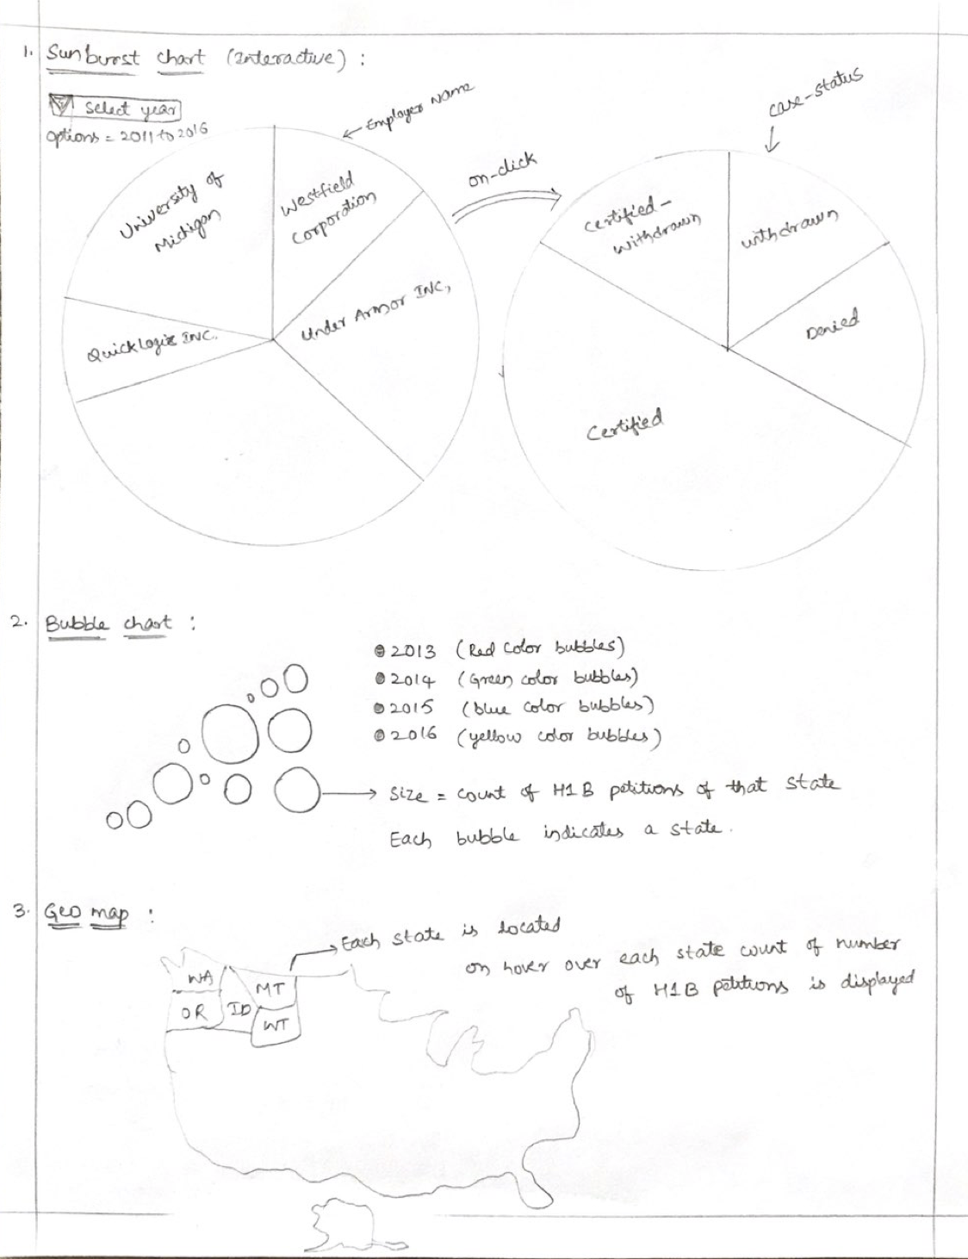

**References:**

<https://www.kaggle.com/nsharan/h-1b-visa>

<https://www.foreignlaborcert.doleta.gov/performancedata.cfm>

<https://www.foreignlaborcert.doleta.gov/docs/Performance_Data/Disclosure/FY15-FY16/H-1B_FY16_Record_Layout.pdf>